MasterCard Personal Expense Management System (MPEMS)
Use Case Model Survey
Filing Reference : | MPEMS_T-1.3.1
Document Title : | Use Case Model Survey
Version : | 0.1a
Prepared By : | - JIANG HAO MIN  - ZHOU ZI FENG  - ALVIN LEE  - GUO YU  - DAO XUAN DUNG
Date Created :
Review By :
 | Lee Zhong De | Date
 | Project Manager

Revision History:
©1993 ISS.  The information contained in this document is the property of ISS. The contents must not be reproduced, wholly or in part, for purposes other than for which it has been supplied, without the prior permission of ISS, or, if it has been furnished under contract to another party, as expressly authorised under that contract. ISS shall not be liable for any errors or omissions. | ISS

Version | Date | Author | Remarks
v0.1 | 08 Apr 2012 | - JIANG HAO MIN  - ZHOU ZI FENG  - ALVIN LEE  - GUO YU  - DAO XUAN DUNG | Initial Draft
v0.1a | 22 Apr 2012 | Zhong De | Refer to amendment history

Distribution:
Name | Department | Organization
Huang Donghao | MasterCard | MasterCard
Dao Xuan Dung | S2 | ISS
Lee Zhong De Rollei | S2 | ISS
Alvin Lee | S2 | ISS
Guo Yu | S2 | ISS
Zhou ZiFeng | S2 | ISS
Jiang Hao Min | S2 | ISS

1. Introduction 3
1.1 Project Client Background 3
2. Survey Description 4
2.1 Registered Member Operations 4
2.2 System Administrator Operations 5
2.3 Non-registered Member Operations 5
2.4 MasterCard Centralized System Operations 5
3. Actors 6
3.1 Registered Member 6
3.2 System Administrator 6
3.3 Non-Registered Member 6
3.4 MasterCard Centralized System 6
3.5 SMS/Email Server 6
4. Use Cases 7
4.1 Login 7
4.2 Logout 7
4.3 Send Email/SMS 7
4.4 Register Account 7
4.5 Confirm Registration 7
4.6 Change Password 7
4.7 Manage Account Details 7
4.8 Manage Credit Cards 7
4.9 Manage Deals Subscriptions 8
4.10 Reset Password 8
4.11 View Dashboard 8
4.12 Assign Budget to All Cards 8
4.13 Assign Budget to Individual Card 8
4.14 Assign Spending Target to All Cards 8
4.15 Assign Spending Target to Individual Card 8
4.16 Compute Budget 8
4.17 Create Credit Card Transaction 9
4.18 Add Transaction Details 9
4.19 Export Transaction Data 9
4.20 Search Credit Card Transactions 9
4.21 Tag Transaction Type 9
4.22 View Credit Card Transactions 9
4.23 View Spending Pattern 9
4.24 Redeem Vouchers 9
4.25 Search Deals 10
4.26 Search Vouchers 10
4.27 View Recommended Deals 10
4.28 View Vouchers 10
4.29 Manage Deals 10
4.30 Manage Merchants 10
4.31 Manage Redemptions 10
4.32 Manage Vouchers 10
5. Use Case Global View Diagram 11
5.1 Global Use Case Diagram 11
5.2 Account Registration 11
5.3 Account Settings 12
5.5 Expense Assistant 13
5.6 Expense Tracker 14
5.7 Perks 14
5.8 Common 15
5.9 System Administration 15

Use-Case-Model Survey for MPEMS

1. Introduction

This project is an academic project supported by Institute of System Science (ISS, NUS). The project client is MasterCard Singapore. The project seeks to develop a system which will provide additional value added services to MasterCard customers. The value added services provided by the new system will enhance customer’s experience with MasterCard and ideally prompt the customers to choose MasterCard as their preferred card.

1.1 Project Client Background

Throughout the world, MasterCard’s principal business is to process payments between the banks of merchants and the card issuing banks or credit unions of the purchasers who use the "MasterCard" brand debit and credit cards to make purchases.



Currently if a customer holds multiple MasterCard from different banks, they will have to manually check their individual card transactions from their card respective banks which can be very inconvenient and time consuming.

The MasterCard Personal Expense Management System (MPEMS) seeks to provide the following value added services to all MasterCard holders

- Single point for user to check all their credit/debit cards transactions that are tie to MasterCard Payment Network

- Expense Tracker, allow user to track and analyze their expenses

- Budget Assistance, allow users to organize their budgets and set reminder when their spending exceed their pre-defined budget

- Exclusive MasterCard Deals, allow users to receive exclusive deals only for MasterCard users

- Rewards Program, allow users to earn reward points by spending on their MasterCard. The reward points can be used to exchange vouchers.

2. Survey Description

2.1 Registered Member Operations
The functions that Registered Member can perform with MPEMS through a user interface are as follows:

- Login
- Logout
- Change Password
- Manage Credit Cards
- Manage Deals Subscriptions
- Reset Password
- View Dashboard
- Assign Budget to All Cards
- Assign Budget to Individual Card
- Assign Spending Target to All Cards
- Assign Spending Targets to Individual Card
- Compute Budget
- Create Credit Card Transaction
- Add Transaction Details
- Export Transaction Data
- Search Credit Card Transactions
- Tag Transaction Type
- View Credit Card Transaction
- View Spending Pattern
- Redeem Vouchers
- Search Deals
- Search Vouchers
- View Recommended Deals
- View Vouchers

2.2 System Administrator Operations
The functions that System Administrator can perform with MPEMS through a user interface are as follows:

- Login
- Logout
- Manage Deals
- Manage Merchants
- Manage Redemptions
- Manage Vouchers

2.3 Non-registered Member Operations
The functions that Non-registered Member can perform with MPEMS through a user interface are as follows:

- Register Account
- Confirm Registration

2.4 MasterCard Centralized System Operations
The function that MasterCard Centralized System can perform with MPEMS is as follows:

- Create Credit Card Transaction

3. Actors

3.1 Registered Member

The Registered Member is an existing MasterCard holder who registered in MPEMS. He/She will be able to view transactions, assign budgets/spending limits, view deals and redeem vouchers through MPEMS.

3.2 System Administrator

The System Administrator interacts with the System by using the Admin functions provided by the System.

3.3 Non-Registered Member

The Non-Registered Member is an existing MasterCard holder who hasn’t registered in MPEMS. He/She is able to register on MPEMS to become a registered member.

3.4 MasterCard Centralized System

MasterCard Centralized System will interact with MPEMS to create new transaction data.

3.5 SMS/Email Server

External SMS/Email Server will be used by MPEMS to send SMS/Email to Registered Member as part of the notification function

4. Use Cases

4.1 Login
This use case allows registered member and system administrator to login into the system to view his or her transaction information. To login to the system, the user will have to enter the login ID and password.

4.2 Logout
This use case allows registered member and system administrator who has already login to logout off the system. User’s session will also be truncated.

4.3 Send Email/SMS
This use case allows the system to send an email or sms to registered members.

4.4 Register Account
This use case allows non-registered member to register account into the system. Upon registration, an email/SMS notification will be sent to the user to notify the user. User will have to confirm his registration by clicking a link in the email and entering a one-time-password that will be sent to his registered mobile phone

4.5 Confirm Registration
This use case allows non-registered member to confirm his/her registration with the system

4.6 Change Password
This use case allows registered member to change password by entering the old and new password and confirming the new password by re-entering it. An email/SMS notification will be sent out to the user once the password has been change successfully.

4.7 Manage Account Details
This use case allows registered member to update their account information such as mobile number, home address

4.8 Manage Credit Cards
This use case allows registered member to add MasterCard to their account. Thereafter, transaction details can be downloaded for users to view. When member is no longer holding the card, he/she could remove the credit card from the account.

4.9 Manage Deals Subscriptions
This use case allows registered member to subscribe and unsubscribe deals that they are interested in.

4.10 Reset Password
This use case allows registered member and system administrator to reset password if the user has forgotten his/her password. An email/SMS notification will be sent out to the user once the password has been reset successfully.

4.11 View Dashboard
This use case allows members to view the summary of their expenditures. This is the default login page

4.12 Assign Budget to All Cards
This use case allows registered members to specify the budgeted amount for all cards expenditure. The system will base on this setting to send out a notification (by email/SMS) if the budget is reached.

4.13 Assign Budget to Individual Card
This use case allows registered members to specify the budgeted amount for individual cards expenditure. The system will base on this setting to send out a notification (by email/SMS) if the budget is reached.

4.14 Assign Spending Target to All Cards
This use case allows registered members to specify the expenditure target for all cards expenditure. The system will base on this setting to send out a notification (by email/SMS) if the target is reached.

4.15 Assign Spending Target to Individual Card
This use case allows registered members to specify the expenditure target for specific card. The system will base on this setting to send out a notification (by email/SMS) if the target is reached.

4.16 Compute Budget
This use case may get triggered when a new card transaction is created. This use case computes if the total transacted amount has exceeded the budget pre-set by the member

4.17 Create Credit Card Transaction
This use case will be called by MasterCard Centralized System where all the real time transactions will go into this system. The transaction data will then be inserted into MPEMS through this function

4.18 Add Transaction Details
This use case allows registered members to add in their own comments on a specific transaction. The member will need to provide the comments. It requires the Member_ID to verify if he/she is the credit card owner

4.19 Export Transaction Data
This use case allows registered members to download transaction information in CSV format. It requires the Member_ID to verify if he/she is the credit cards’ owner.

4.20 Search Credit Card Transactions
This use case allows registered members to search through all their own credit card transactions. They will need to provide a Start and End Date. It requires

4.21 Tag Transaction Type
This use case allows registered members to tag a category on a specific transaction. The member will need to select from a pre-defined list of categories. It requires the Member_ID to verify if he/she is the credit card owner.

4.22 View Credit Card Transactions
This use case allows registered members to view specific credit card transactions. They will need to provide a Start and End Date. It requires the Member_ID to verify that he/she is the credit card owner.

.

4.23 View Spending Pattern
This use case allows registered members to view spending pattern by period, cards or transaction type. It requires the Member_ID to verify if he/she is the credit cards’ owner.

4.24 Redeem Vouchers
This use case allows registered members to redeem vouchers using their reward points

4.25 Search Deals
This use case allows registered members to search for all existing mastercard deals

4.26 Search Vouchers
This use case allows registered members to search for all vouchers redeemable by members

4.27 View Recommended Deals
This use case allows registered members to view recommended deals based on MPEMS personalized recommendation algorithm

4.28 View Vouchers
This use case allows registered members to view all vouchers redeemable by members

4.29 Manage Deals
This use case allows system administrator to search, create, retrieve, update and delete master card deals.

4.30 Manage Merchants
This use case allows system administrator to search, create, retrieve, update and delete merchants

4.31 Manage Redemptions
This use case allows system administrator to search, retrieve and update redemption status.

4.32 Manage Vouchers
This use case allows system administrator to search, create, retrieve, update and delete vouchers redeemable by members

5. Use Case Global View Diagram

5.1 Global Use Case Diagram

5.2 Account Registration

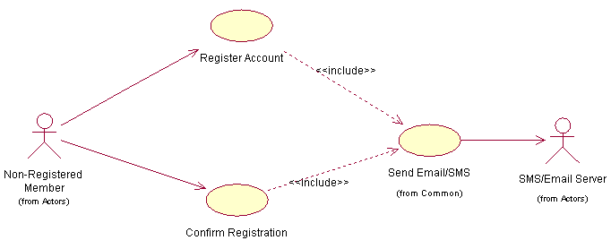

5.3 Account Settings

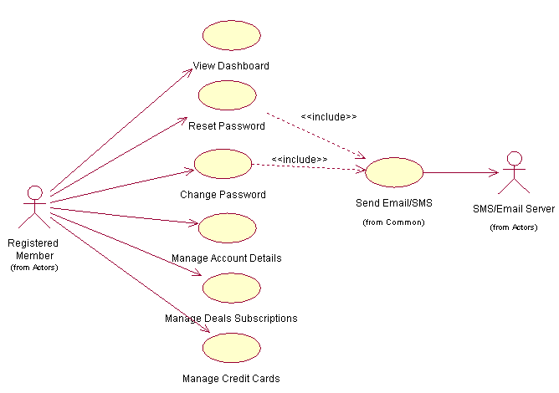

5.5 Expense Assistant
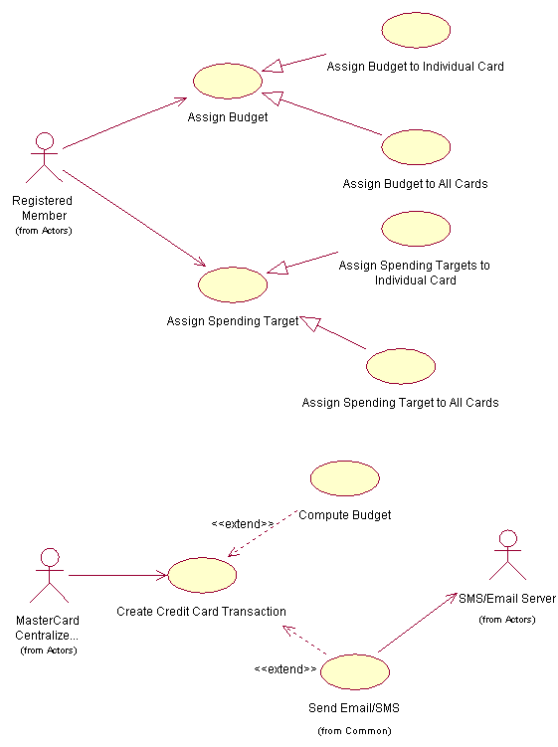

5.6 Expense Tracker

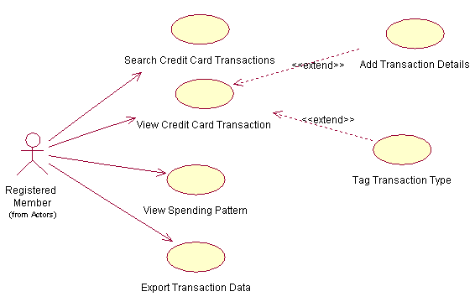

5.7 Perks

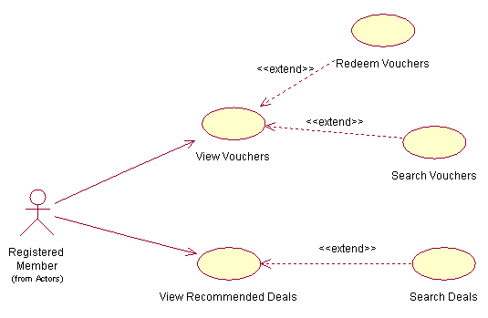

5.8 Common
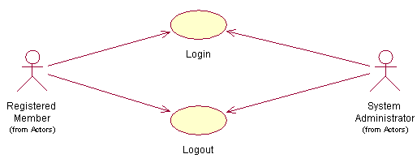

5.9 System Administration
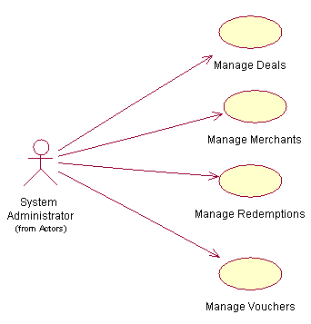

Version | Section | Remarks
v0.1 | 08 Apr 2012 | Initial Draft
v0.1a | 22 Apr 2012 | - Changed format to adhere to MPEMS document format  - added new use case “View Dashboard”  - added in missing actors

